PREPROCESSING AND ARTIFICATS LEARNING FOR CLOUD POINTS
ModelNet40:
The dataset contains 40 classes and 12,411 CAD objects and for GNN purposes we convert them into point clouds.
Uses. OFF that must be converted into point clouds as raw meshes cannot be used -> [N,3]
Stage -1:
- Point sampling, each class has its own different number of points, so we uniformly sample 1024 points from the vertices. If there are fewer than 1024 vertices, its samples with replacement
- We make the translation invariant by cantering at mean and dividing by max distance thus making a small chair like a large scale
- We try to get the normal that is the face of the points via PCA, For each 1024 points we find the kth 10 best neighbours using a KD-tree and fit a local plane to these 10 neighbours by computing a 3x3 covariance matrix
- The eigen vector with the lower eigen value becomes the normal for that point/ surface
- 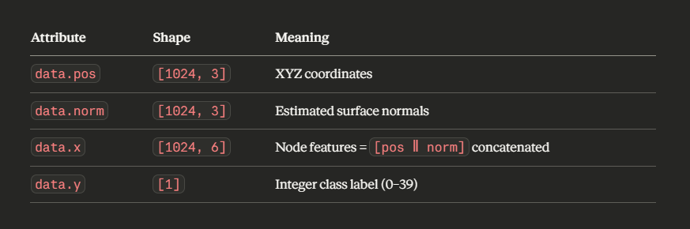
- So, for each point we have a 6D feature vector that the GNN will consume, we get where it is and what direction its facing
- KD-tree – a Data structure that is used to organizing data in kth dimensional space.
- Imbalance ratio around 13.9x: so, we need to weight or use focal loss
- 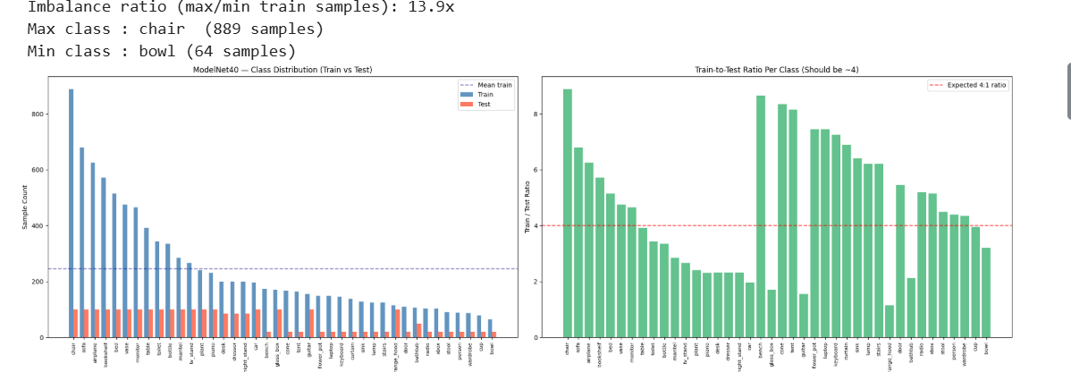
HOW SURFACE NORMALS ARE FOR SOME X CLASSES:
- Take the unit vectors from some x classes -> [nx , ny , nz]
- Plotting nx and nz on y axis we can tell how many normal’s point in that direction
- Hot = many normals pointing there
- Normal Entropy score:
  - Uses Shannon entropy to understand how spread out the normals are
  - Low entropy: Normals concentrated in few direction -> flat geometry
  - High entropy: Normals spread everywhere -> complex geometry
  - Example how to interpret
    - Cone has Zero entropy: Model can classify it from normals alone with very few points
    - Plants fills the full sphere -> Models need positional features , not just only normals
    - Thus we need the 6d FEATUES
    - 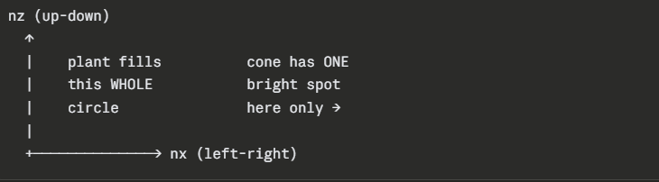
  - Shannon entropy why needs deep reasoning:
    - Entropy: How unpredictable is this class score is given to each class
    - This is exactly why the node features are 6D = [x, y, z, nx, ny, nz] instead of just 3D — you are giving the GNN Student B's hands, not Student A's.
    - 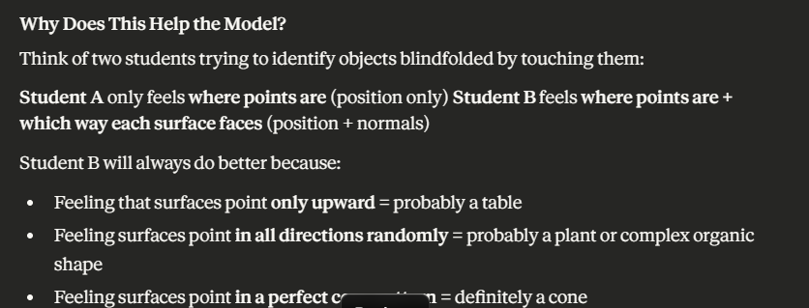
- Density Heatmaps:
  - Instead of looking at which way surfaces face(normals), this looks at where the points physically are in the 3D space
  - We investigate top view (XY) , front view (XZ) , side view (YZ)
  - 50 samples x 1024 -> 51200 points get piled up and projected onto the 2D plane and counted into a 50x50 grid. Bright yellow means many points pile up here and dark purple means = empty space
  - The bright regions are where the GNN’s attention should naturally focus – they’re the highest information zones where ethe most points consistently appear across many samples in that class
- CHAMFER DISTANCE
  - For every point in object A , how far is its nearest neighbour in object B – and vice versa
  - Average everything we get the chamfer distance
  - Small number = objects are grammatically similar
  - Larger distance = objects looks very different hence they are far apart
  - Dark Red -> Low distance = same shapes harder to classify – high confusion risk
  - Bright yellow -> High distance – easy to separate
  - White diagonal = zero identical to itself
  - This is a difficulty map for us
  - 